CONDUCTION OF PHD ENTRANCE EXAMINATION: (NURSING)

Sl No | Events | DATES
1. | Date of Notification | 10/03/2023
2. | Hosting of the Brochure and Application form on the website | 14/03/2023
3. | Last date for online Payment | 12/04/2023  Before 05.00 P.M
4. | Last date for receipt of print-out of applications filled online by Post or In person before 5-00 P.M at RGUHS. | 21/04/2023
5. | Date of availability of Hall-Ticket for the  Eligible candidates | 29/04/2023
6. | Date of Entrance Exam | 04/05/2023
7. | Provisional Result | Second week of June - 2023
8. | Submission of preliminary Synopsis by qualified candidates | Second week of July - 2023
9. | Presentation of Synopsis before the Committee | Third week of August- 2023
10. | Commencement of Session | September - 2023

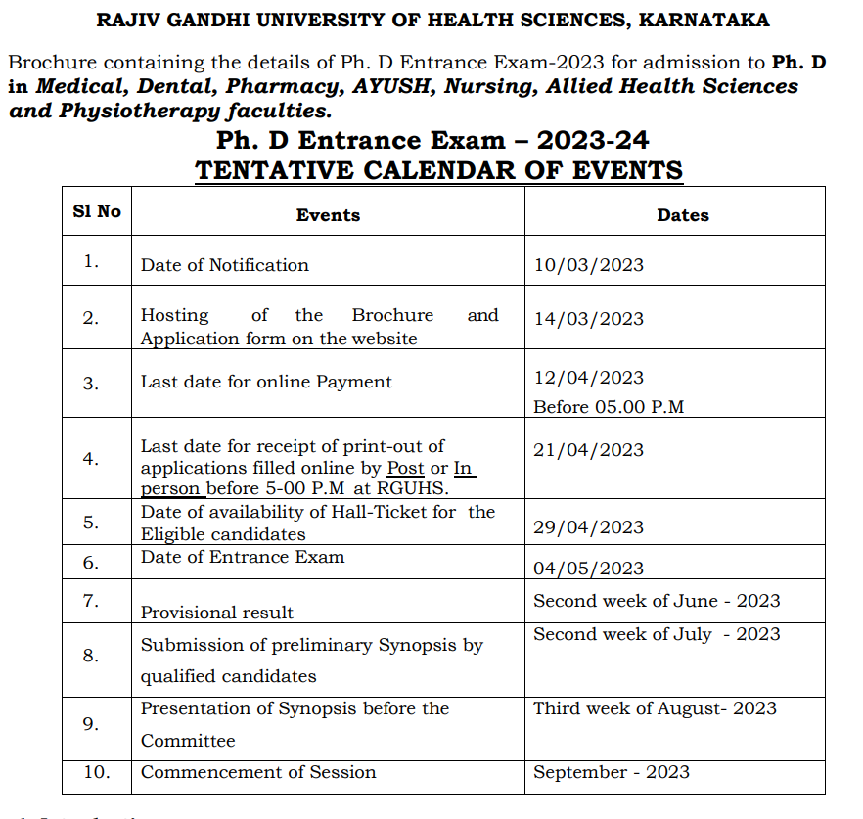

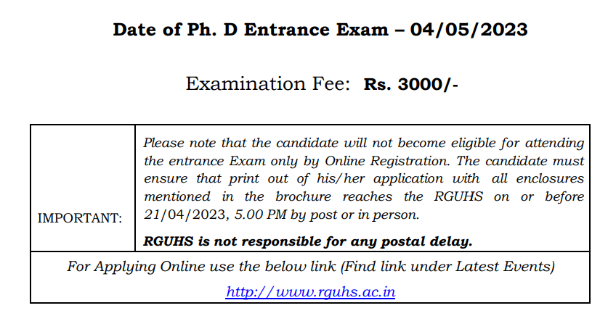

SYLLABUS FOR ENTRANCE EXAMINATION:The Entrance Exam Is Conducted In Two Parts Namely

1. Principles of Basic Research Methodology : Paper - I
2. Speciality Paper : Paper – II
The specialty paper Syllabus content shall ordinarily be equal to the Syllabus and Books prescribed for Post-Graduate Course for that subject as per Regulations of Indian Nursing Council and/ or the Rajiv Gandhi Universities of Health Sciences.
The Principles of Basic Research Methodology Syllabus is as follows:
(1) Research Methodology: An Introduction
(2) Defining the Research Problem, Hypothesis, Generation of Hypothesis
(3) Research Design
(4) Sampling Design
(5) Measurement and Scaling Techniques
(6) Methods of Data Collection

(7) Processing, Statistics and Analysis of Data
(8) Sampling Fundamentals
(9) Interpretation and Report Writing
(10) Principles and Methods of fundamental research method, literature, drug and research problem survey, clinical research
(11) Writing an article for a scientific journals
(12) Bioavailability
(13) Bioequivalence
(14) Clinical Trials.

4.1 Duration, Nature of Question Paper and Answer Booklet:

There are separate papers for

- SPECIALTY SUBJECT - with 50 marks and
- BASIC RESEARCH METHODOLOGY paper - with 50 marks.
- Paper - I Question paper comprises of 8 Questions of 10 Marks each.
- Paper - II Question paper comprises of 8 Questions of 10 Marks each.
- The candidate shall answer ANY FIVE QUESTIONS out of Eight Questions in both the papers.
- Duration of examination is THREE HOURS AND SEPARATE ANSWER BOOKLETS are issued for each paper.

Eligibility:- A candidate who fulfills the following criteria shall be eligible to appear for the Entrance Exam, namely :
(i) He/ She is a citizen of India;
(ii) He/ She has studied and passed in the courses leading to the award of PG degree/ diploma in respective branches recognized by respective councils/Government of India and affiliated to any University established by Law.
(iii) A Post graduate qualification in the concerned Specialization and faculty is a must.
(iv) The candidate who completed his/her post graduate degrees in respective branch are eligible for that branch/subject only.

- Candidates with M.Sc/M.Phil in Nursing degree awarded by this University or a College/University recognized by INC or a P.G. Degree in Nursing considered as equivalent by INC are eligible for enrollment for Ph. D course in concerned subjects of Nursing.

- All the candidates intending to register for Ph.D. programme shall appear for the Entrance Exam conducted by the University.
- An Entrance Test shall be qualifying test with qualifying marks as 50th Percentile. Percentile method be adopted for declaration of the result. The test consists of two papers, conducted over two sessions of three hours. The syllabus of the first theory paper consists of Basics of research methodology and will carry 50 marks.(10X5) The Second theory paper which will be subject specific, preferably with the competence of PG standard, will carry 50 marks.(10X5) There shall be eight questions with each questions carrying ten marks. The candidate shall answer any five questions out of eight questions in both the papers.
- The marks scored by the candidate for both the papers put together be considered for deciding the pass criteria.
- Percentile method is adopted for declaration of the result. Faculty wise 50th percentile shall be cut off point to declare for having passed Ph D entrance examination.
- If multiple candidates score equal marks in entrance examination, ranking will be based on marks scored in Post Graduation examination. In case, the Post Graduation marks are also same, then Under Graduate marks will be considered. If the Under Graduate marks are also same, then candidate who is senior in age will be considered for higher ranking.
- The Entrance Exam shall be conducted at the Centre(s) notified by the University.
- The Provisional list of affiliated institutions importing Ph. D course along with course in which Ph. D is offered and the list of Ph. D Recognized guides available in the Institutions is put on the website for candidates reference.
- The candidates who successfully clear the Entrance Exam are invited to discuss their research interest/area through a presentation before a duly constituted University Ph.D.
Registration committee of the respective faculty.
The interview/viva voce will also consider following aspects, viz. whether:
(i) To evaluate the research aptitude of the applicants
(ii) The candidate possesses the competence for the proposed research.
(iii) The research work can be suitably undertaken at the Institution/College.
(iv) The proposed area of research can contribute to new/additional knowledge.

5. APPLICATIONS are liable for rejection:

A. If Incomplete.
B. If Photograph not uploaded.
C. If photographs are found mismatched in the application.
D. If photographs are not recent one and not attested by a Gazetted Officer.
E. If the applicant has not signed in the application.
F. If supporting documents (Enclosures) not attested.
G. If eligibility is not fulfilled

6. How to submit:
By Post or In-person:
- Print out of application filled online, along with attested copies of all required certificates shall be sent by post or In-person for registration to “The Registrar, RGUHS, 4th ‘T’ Block, Jayanagar, Bangalore – 560 041” by 21/04/2023, before 5.00 P.M.
- Candidates should super scribe on the cover as “Application for Ph.D Entrance Exam-2023”.
- Please note that the candidate will not become eligible for attending the Entrance Exam, only by online registration.
- The candidate must ensure that print out of his/her application with all enclosures mentioned in the brochure reaches the RGUHS.
- The University does not hold responsibility for loss or delay in postal delivery.

Enclosures: ( Attested copies)
a) SSLC Marks card.
b) UG and PG Degree Certificates with Marks cards.
c) Registration Certificate from the State Council in applicable cases.
d) NOC from the Head of the Institution where the candidate is employed.
e) Fee paid details: Transaction-Id with date.
f) Any other relevant documents.
7. Entrance Exam Fee: - Rs.3000/-
Mode of Payment: -Through ONLINE PAYMENT.
Note: Registration fee is not refundable under any circumstances.
8. Conduct of Entrance Exam:

Date Time Place
04/05/2023 10-00 A.M. to 01-00 P.M. Bangalore only
SYLLABUS:-
The entrance exam is conducted in two parts namely
1. Principles of basic Research methodology – Paper - I
2. Specialty paper - Paper – II

SYLLABUS :The Principles of Basic Research Methodology Syllabus is as follows:
(1) Research Methodology: An Introduction
(2) Defining the Research Problem, Hypothesis, Generation of Hypothesis
(3) Research Design
(4) Sampling Design
(5) Measurement and Scaling Techniques
(6) Methods of Data Collection
(7) Processing, statistics and Analysis of Data
(8) Sampling Fundamentals
(9) Interpretation and Report Writing
(10)Principle and methods of fundamental research method, literature, drug and research problem survey, clinical research
(11) Writing an article for a scientific journals
(12) Bioavailability
(13) Bioequivalence
(14) Clinical Trials

- The specialty paper Syllabus content shall ordinarily be equal to the syllabus and books prescribed for Post-Graduate Course for that subject as per Regulations of Central Council and/ or the Rajiv Gandhi Universities of Health Sciences.

9. Duration, Nature of Question Paper and Answer Booklet:
- There are separate papers for specialty subject with 50 marks and Basic Research Methodology paper with 50 marks.
- Paper I question paper comprises of 8 questions of 10 marks each. Paper – II Question paper comprises of 8 questions of 10 marks each. The candidate shall answer any five questions out of eight questions in both the papers.
- Duration of examination is three hours and separate answer booklets are issued for each paper.

Duration, Nature of Question Paper and Answer Booklet:
- There are separate papers for specialty subject with 50 marks and Basic Research Methodology paper with 50 marks.
- Paper I question paper comprises of 8 questions of 10 marks each. Paper – II Question paper comprises of 8 questions of 10 marks each. The candidate shall answer any five questions out of eight questions in both the papers.
- Duration of examination is three hours and separate answer booklets are issued for each paper.

PENALTY FOR FALSE AND INCORRECT STATEMENTS:
- Where an applicant has furnished any false and incorrect statement in the application or where the affidavit filed by him or the certificate furnished by him contains any false or incorrect statement, the application shall be liable for rejection and his selection for admission to the Ph. D course shall be cancelled after providing a reasonable opportunity to explain by the Ph. D Registration Committee.
Malpractice: Any candidate indulging in mal-practice in any sort shall be viewed seriously and punished and also is liable for criminal proceedings.
12. Instructions to Candidates:

- The candidates shall be present at the centre 30 minutes before the commencement of the Exam by 9.30 A.M
- No candidate is allowed after 10:00 AM.
- Only the candidates who possess the Hall Ticket shall be allowed to appear for the Entrance Exam. In case of loss of Hall Ticket, the candidates should contact the Chief Superintendent of the centre one hour earlier for assistance.
- No Candidate shall copy from the paper of any other candidate or permit his /her own papers to be copied or attempt to give or seek any illegal assistance.
- No candidate will be allowed to the examination hall after the commencement of the Entrance Exam.

- No candidate will be allowed to leave the examination hall before the end of the first thirty minutes. Candidates leaving the hall prior to the end of the Entrance Exam will have to hand over the question paper to room invigilator and collect the same at the end of the Exam.
- Candidate should sign the attendance sheet as per the instructions of the invigilator.
- Silence must be observed in the examination hall. Any candidate found guilty of disorderly or improper conduct will be liable for expulsion from the examination hall and will be debarred from the Entrance Exam by the Chief Superintendent of the centre.
- Candidates are not permitted to carry any electronic gadgets like Pager, Cell Phone, Bluetooth etc., into the examination hall.

